**ĐẠI HỌC KHOA HỌC TỰ NHIÊN TP.HCM**

**KHOA TOÁN – TIN HỌC**



BÁO CÁO MÔN  
**TÍNH TOÁN DI ĐỘNG**

**Đề tài:**

**PICPIC**

Ứng dụng camera phone

**Giảng viên hướng dẫn:**

TS. Trần Anh Tuấn

**Sinh viên:**

Tạ Hoàng Thảo Vy – 1511353

Contents

Project Setup 3

Requirement: 3

How to setup: 3

Frontend application: 4

Main screen: 4

Take photo screen: 5

Edit photo screen: 6

Backend & functions: 14

Load edited photos by GridView 14

Camera and editor config: 15

Permission: 17

Touch listener: 17

Class Application: 18

# Project Setup

## Requirement:

* Android Studio
* Real Android Phone

## How to setup:

* Install what android studio require: build tool, api platform, …
* Build project, if error appear. Clean project and build again.

# Frontend application:

## Main screen:

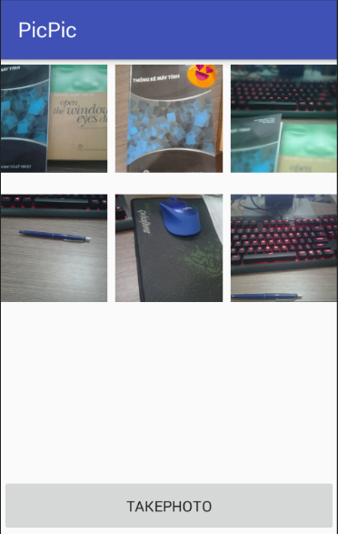

## Take photo screen:

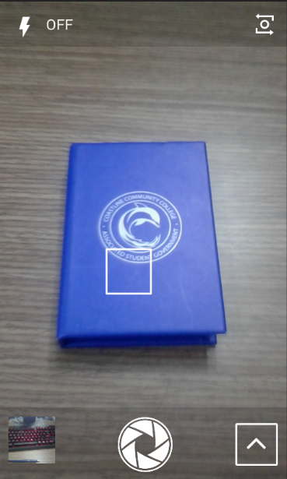

* There are some options while taking the photo

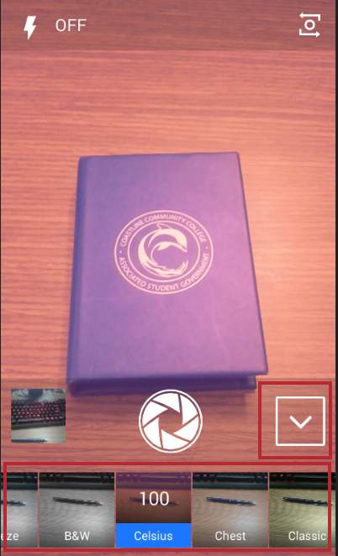

* Change to front camera and active flash mode:

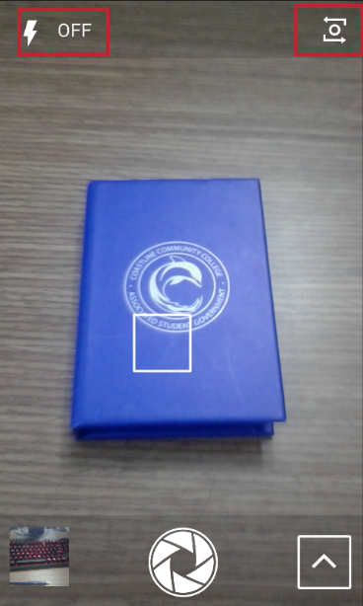

## Edit photo screen:

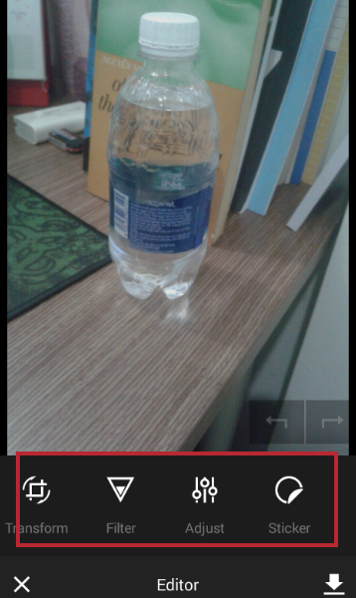

* Transform:

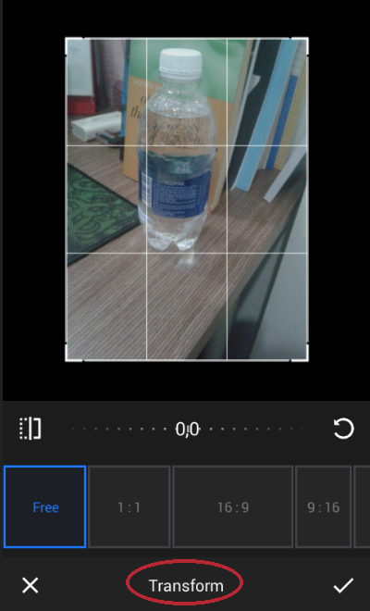

* Filter

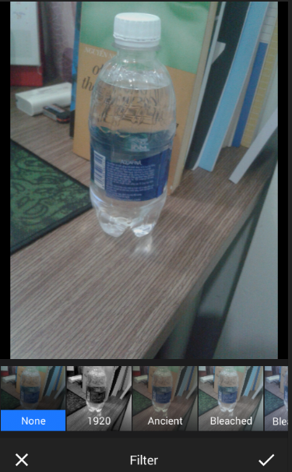

* Adjust: this feature has some more options: Brightness, Contrast, Saturation, Clarity, Shadow, …

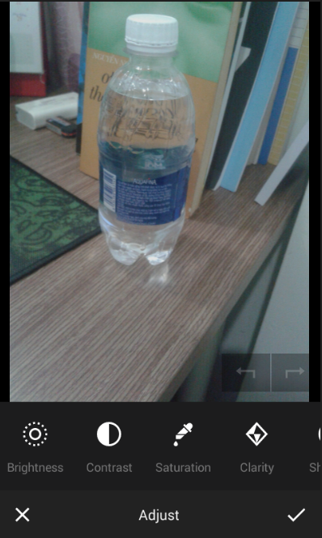

* Sticker:

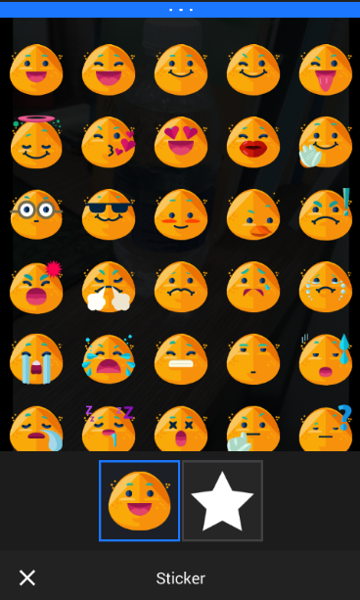 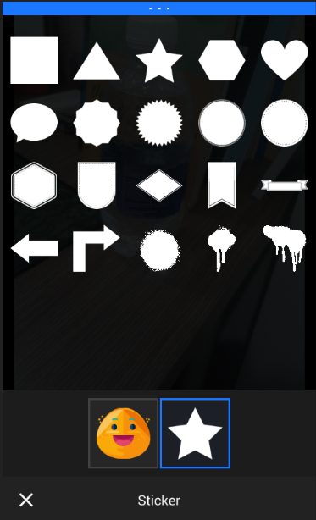

* Text:

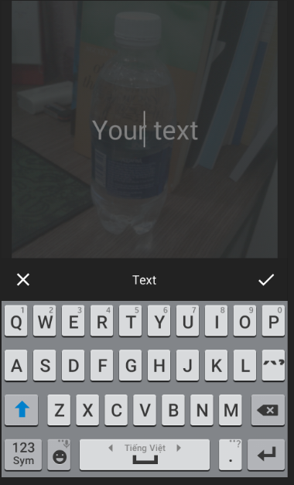

* Overlay:

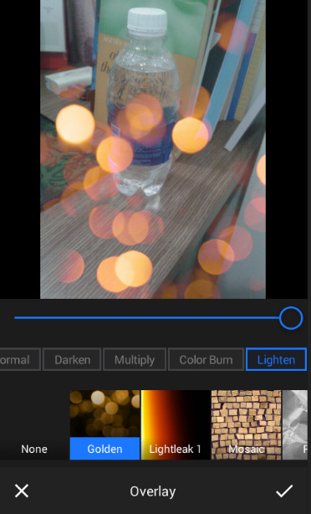

* Frame:

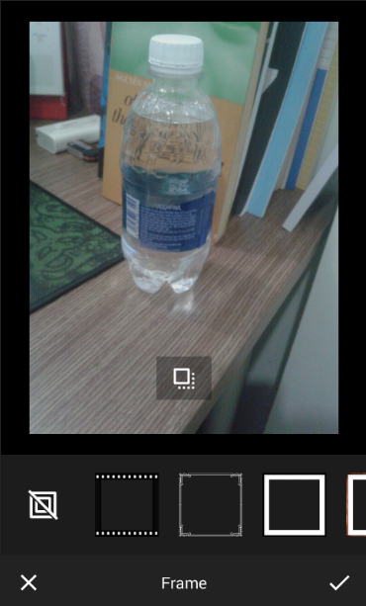

* Brush:

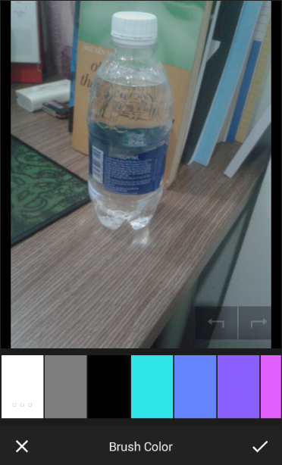

* Focus:

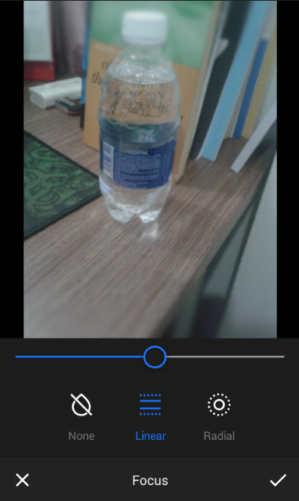

* After all, an example:

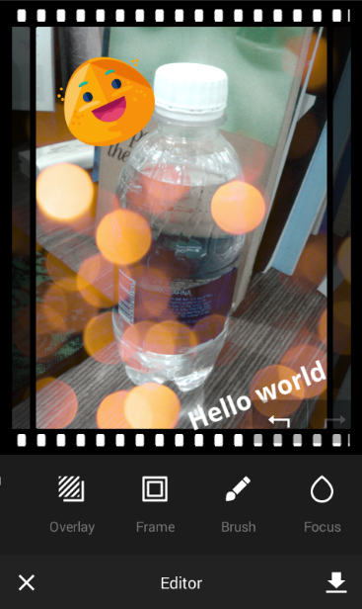

* Save edited image:

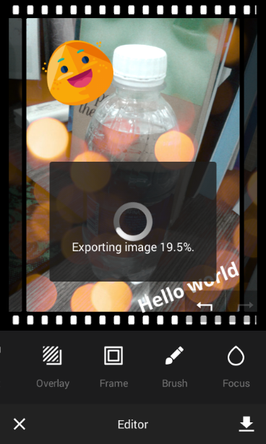 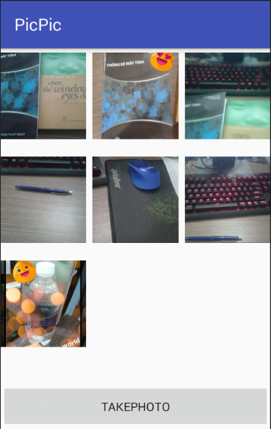

# Backend & functions:

## Load edited photos by GridView

* Class ImageAdapter extends from BaseAdapter is needed for gridView to contain data (images).

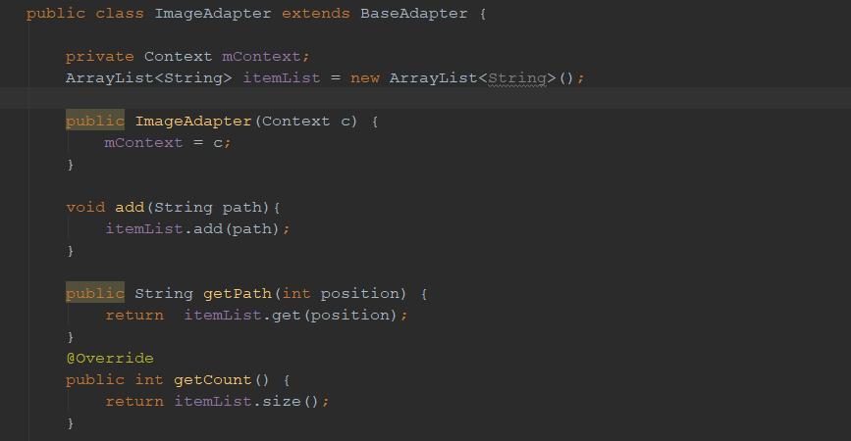

* Function loadPhotos() read photos from device and load to imageAdapter. This function be call every app start and every time you save edited image.

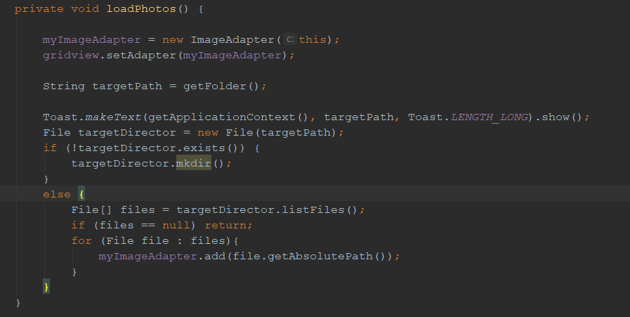

* Photo get from device are encoded. Function decodedBitmapFromUri() to make it visible to user. 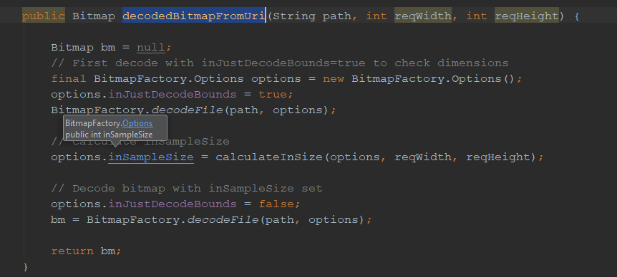
* **Note**: file path is important, unique path is required for save and load photos. I wrote function getFolder() to solve that.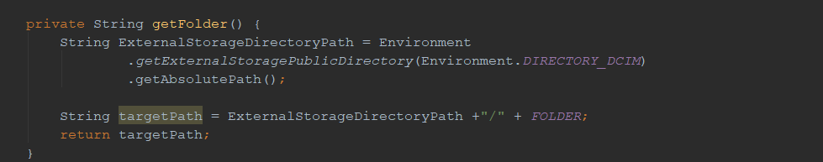

## Camera and editor config:

Function startCamera() config some attribute (layout, export directory, export prefix name, save option) and then open the camera with call back. In this case, function is startActivityForResult()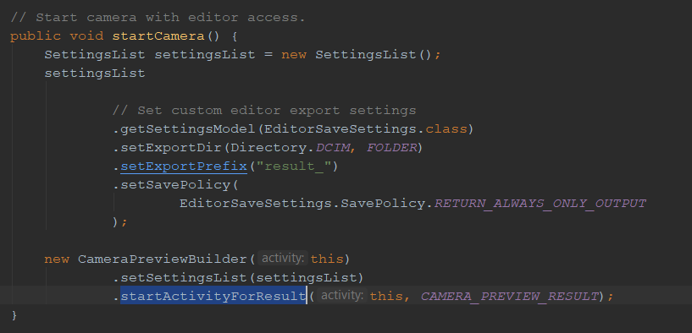

* Familiar with function startEditor(). Those two function are implemented callback with onActivityResult() - member method of AppCompatActivity class 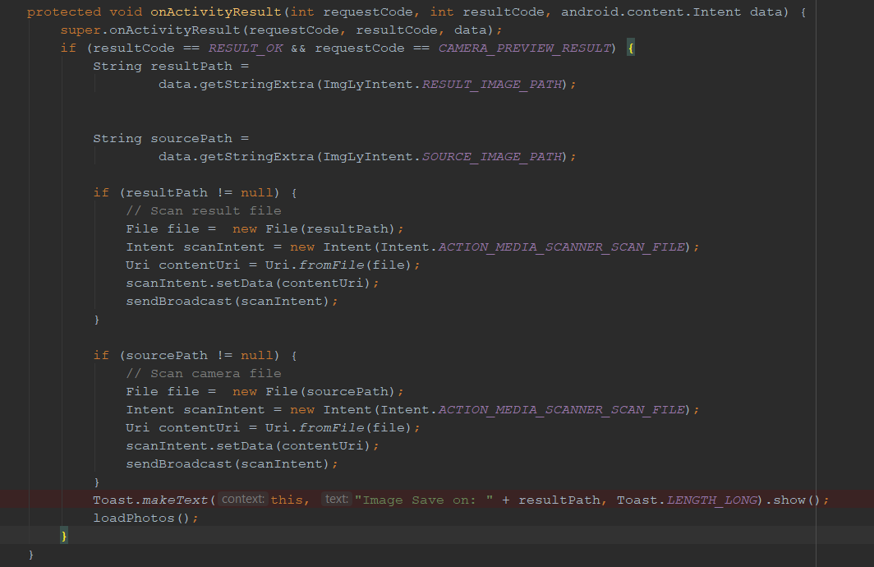

Permission:   
App auto request permission. But i wrote callback to handle if user allow or not. 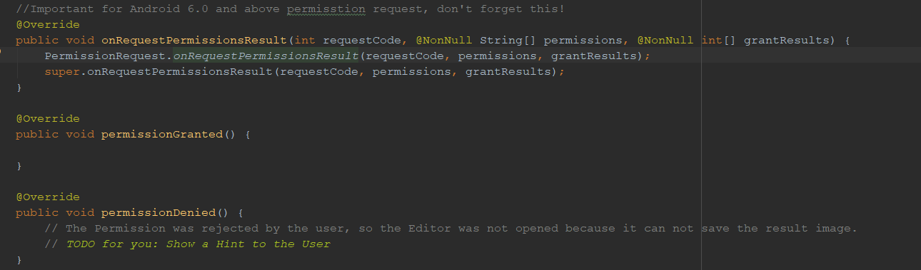

## Touch listener:

* Button “Take Photo” adding listener

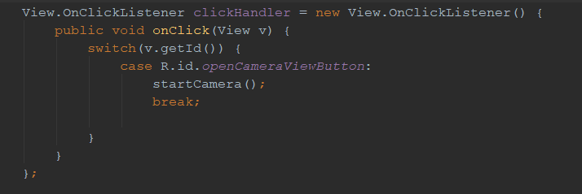

* Photo from gridView adding touch listener

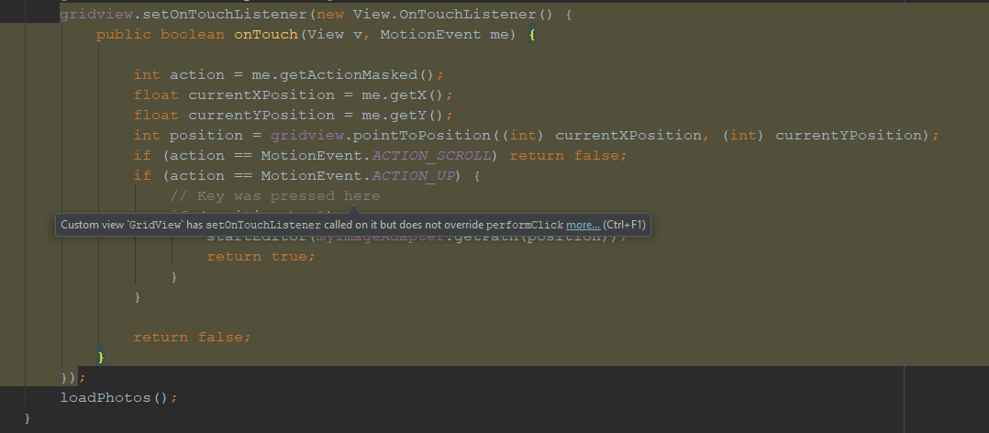

## Class Application:

* I added class Application to initialize camera and editor plugins variables

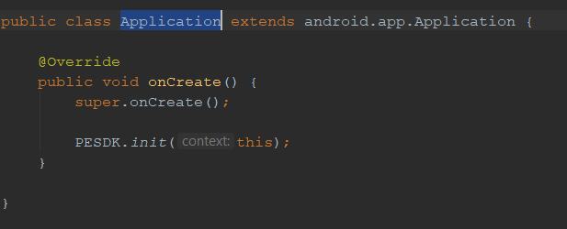

* Add to AndroidManifest.xml is required.

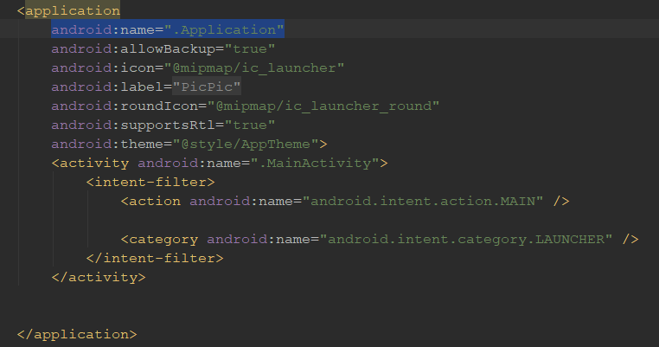

END.